TO: Tuition Exchange eligible employee
FROM: TELO Officer
RE: TE-EZ Application process is available on line

Tuition Exchange, Inc provides the opportunity for you to complete the Tuition Exchange application on line. This application process is for new Tuition Exchange applicants only. Current Tuition Exchange recipients should not complete a new application.
The application is found at www.tuitionexchange.org inside the Family Bucket.
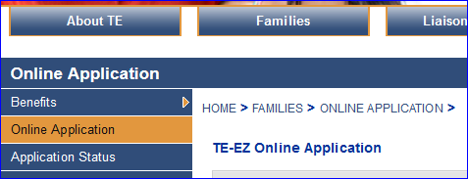
The completed application record is sent to my attention for review and certification. Please be aware, completing the application does not mean your dependent seeking Tuition Exchange will receive the opportunity for export.
INSERT SCHOOL GUIDELINES OR LOCATION OF GUIDELINES HERE
Be sure you read carefully the information provided before beginning the process of entering your dependent student’s data. The system will provide a maximum of ten school choices. Any comments you provide on the application is shared only with the Export school.
This new application process option allows you the opportunity review the status of your dependent’s TE application up to the point that it is certified by your TELO and forwarded to the selected school(s). You will later hear from me and most likely the importing school(s) about if your TE scholarship request is granted. Please be sure to enter a valid email address, the last 4 digits of the student’s social security number, and the student’s actual birthdate on the initial application. This is the only way you can review your student’s TE application status.

