June, 2015 Close Out Webinar FAQ’s.

Double Credit 3

- Q. What are the other TE programs besides TE and CIC?
A. TE Recognized Double Credit 3 Exchange Programs
As of January 2015
- Council of Independent Colleges (XPCIC)
- Council for Christian Colleges and Universities (XPCCCU)
- Catholic College Cooperative Tuition Exchange (XPCCCTE)
- Association of Jesuit Colleges and Universities (XPAJCU)
- Evangelical Lutheran Churches in America (XPELCA)
- Associated Colleges of the South (XPACS)
- Great Lakes Colleges Association (XPGLCA)
- Associated Colleges of the Midwest (XPACM)
- Association of Presbyterian Colleges and Universities (XPAPCU)
- . Associated Colleges of the Twin Cities (XPACTC)

Updating Student Records

- Q. Who enters "enrolled"? The exporting school or importing school? What if there is a conflict with this?
A. The Exporting school is allowed access to the entire student record and can update the record – this will require communication from the student/employee. The Importing school can also enroll the student by checking the Enrolled box.
- Q. If a student was an import during the 2013-14 school year and attended all year; but fails to return for the 2014-15 school year, are they a “DROP STUDENT”?
- The answer to this question is DROP STUDENT
- For the student who DROPS during the school year – select DROP Student. This sets the students expiration date to the end of that term.
For the student who NEVER ENROLLs – select DELETE Student. This eliminates the student from the database.

- Q. If we delete someone that did attend for one year, would it take away from the 5 year balance for credit on our balance sheet?
A. Yes, if you delete a student it removes the student completely from the Database. Please contact Janet so that together, we can get the deleted student back into the system.
- Q. If we find out after the fact, that an employee’s child did a semester abroad, how do we adjust for the 1 semester?
A. There are several factors inside this question. 1. Did the student use TE dollars to help fund the study abroad experience? If yes – what will your school do to recoup those dollars? If nothing, then the student used the semester. You need to create a mechanism to catch that in the future. 2. If the student did not use TE dollars to fund the experience – this time you can notify Janet (jdodson@tuitionexchange.org) with the student’s TE ID and the updated expiration date. We will need to over-ride the system and I can help you do that. 3. In the future, you should drop the student during the semester he is studying abroad. This will cancel the semester count for the student.
Another reason to review your Annual Report each enrollment period so that you can able to update and correct student records during the semester in which the update is occurring.

- Q. In the Decision section, would it be possible to leave the Reject button there and add a Declined button to indicate TE was offered but declined by the student? This would clear up confusion on the decision change.
A. I will visit with IT about this request. Thank you for the suggestion.
- Q. So if I approve a student that was accepted into the college (and the student paid the deposit) but they never began enrollment, will I need to delete this student from our annual report?
A. To preserve the student’s record – you should select DROP STUDENT.

- Q. To claim the student does the exporting institution make the claim and then confirm with the importing institution that the student is confirmed?
A. The Exporting school is allowed access to the entire student record and can update the record – this will require communication from the student/employee. The Importing school can also enroll the student by checking the Enrolled box.

- Q. Where do you find and click the box for wait list and withdrawn. I know I see it initially when I put a student in but can't find it on existing ones.
A. The Importing school finds this inside the View Submissions section of View Applications. Only the Importing School will have records that require a Decision of Approved, Rejected, and Wait List and in the case Withdrawn is not an option.

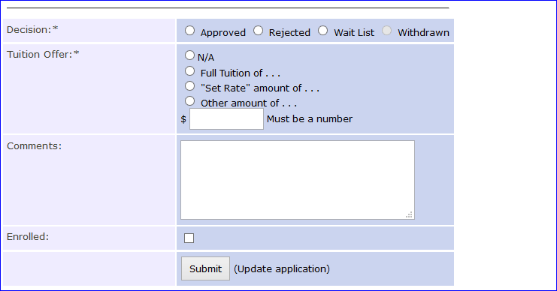
Miscellaneous Questions

- Q. In reviewing the Annual Report and clicking on an individual student, the option of drop and delete but I don't see enroll or wait list and the other options.
A. Correct – this is the in View Submission section of NEW applicants only.

- Q. Why August 15 for certification? That is too early!
- Schools are looking for information about who is coming, not coming and so on. August 15 has little to do with census it has everything to do with cleaning up the system. By working with your Admissions and Financial Aid staff, even the Registrar, I am fairly confident they know who is solid and who remains questionable for your fall enrollment.
3. Q. Students are not considered "enrolled" until the school's census date.
A. And that is why the Annual Report is not due until October 30. However, it is important to claim and/or reject students you have information for. This helps everybody clean up the system. We encourage you to work with your Admissions and Financial Aid staff, even the Registrar, I am fairly confident they know who is solid and who remains questionable for your fall enrollment.
4. Q. What if the parent is no longer employed at our school.
A. Generally, this means the student is no longer eligible. You need to DROP STUDENT so that the expiration date is re-set and notify the other school immediately!
5. Q. Where can I access the TE handbook?
A. The TE Handbook is inside the TELO ONLY Resource section of the website. It is found inside the Communications folder. Need the login details – check at the TELO Portal login screen at the bottom.

6. Q. What happens if you don't receive our annual fee payment by July 1st?
A. A late fee will be accessed if Membership dues are not received by December 1.
7. Q. If you do not want emails being sent out to your students and their parents, can you opt out of this?
A. At this time, there is no opt out option for individual schools. The only way to opt out today is to NOT provide the email address. If this is your option – please be aware that from your side the family will receive no email correspondence. However, if the other school does add the email address that will void your decision of none.

